## The Text Box Tool

The Text Box is created in a similar way to the Text Object tool but the products are different. The difference between the **Text Object** and the **Text Box** tools is the Text Object literally creates an object that can be stretched and manipulated like any other in RapidPlan, whereas a Text Box is literally a text box.

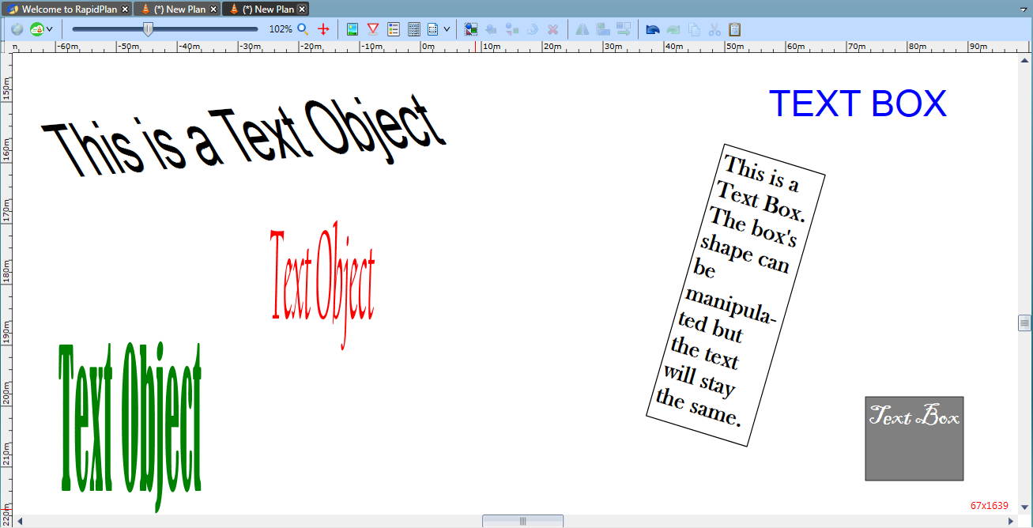

Text_Object_vs_Text_Box